
- What is jQuery
- Features of jQuery
3. Brief introduction about our application
3.1 The function of our application
3.2 The description of our application
4. Basic knowledge about jQuery
4.1 Installation
4.1.1 Download the jQuery
4.1.2 Include jQuery from a CDN
4.2 Basic syntax
4.3Different selectors
4.4Events
5. jQuery Effects
6. jQuery DOM Manipulation
7. jQuery Traversing
8. jQuery AJAX
9. why jQuery
10.reference
1. What is JQuery
jQuery is a cross-platform JavaScript library designed to simplify the client-side scripting of HTML. jQuery is the most popular JavaScript library in use today, with installation on 65% of the top 10 million highest-trafficked sites on the Web. jQuery is free, open-source software licensed under the MIT License .[ Wikipedia]

- Features of jQuery
jQuery includes the following features:
HTML/DOM manipulation
CSS manipulation
HTML event methods.
Effects and animations
AJAX
Utilities

- Brief introduction about our application
  - The function of our application
Our application is a web puzzle game.
The users have to complete a puzzle of German map in the website. The game has two modes, the easy one and a hard one. In easy one, the user will have 45 seconds to complete the mission, and the hints of the states figure will be given to help the player find the right position. In the hard one, the player will have 30 seconds in completing the map without any hints. After the puzzle is completed or the time runs out, the results of scores and times will be shown to the player.
  - The description of our application
The basic structure of our application:
We create a table with 11*18 points in the center of the web to record the click postion of the player on the map.
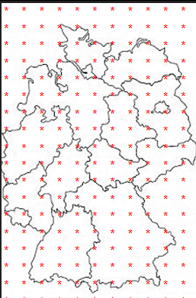

With jQuery function, we can control the attributes of these points. For example, we use the function to change their class or id the make the mapping between map and table.

$(".Baden-Wuerttemberg").click(function(){
if(game_stop == false){
if($("#x00").html() == "Baden-Wuerttemberg"){
$("#grid").children("#map").css("background-image","url(photo/1.png)");
success = true;
puzzle.next();
}else{
alert("this is Baden-Wuerttemberg");
}
}else{
alert("game is stop");
}
});

With jQuery event and CSS manipulation, we complete the part of the hints in easy mode, The picture will move automatically with the mouse in the easy mode.
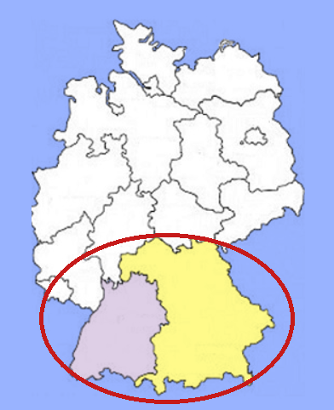
Within the game, we also use the HTML/DOM manipulation to do the count down and calculate how many points the user has got to make the game more interesting.
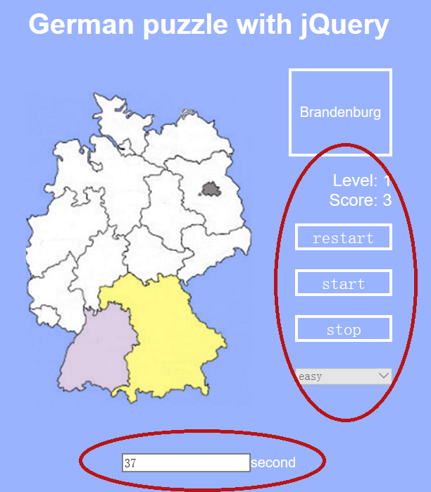

- Basic knowledge about JQuery
  - Installation
There are two ways to start using jQuery:
1) Download the jQuery library from Jquery.com
2) Include jQuery from a CDN, e.g(Google , Microsoft)

4.1.1 Download the jQuery
The jQuery library is a single JavaScript file. Firstly, you can download the Production version or Development version from jQuery.com
Then, you reference it with the HTML <script> tag like this:
<head>
<script src="path of your jQuery file"></script>
</head>

4.1.2 Include jQuery from a CDN
If you don't want to download and host jQuery yourself, there is another choice.
You can choose to include it from a CDN (Content Delivery Network).
<head>
<script src="https://ajax.googleapis.com/ajax/libs/jquery/3.1.1/jquery.min.js"></script>
</head>
Let’s take Google as an example:

  - Basic syntax
In jQuery, the basic syntax is:
$(selector).action()
A $ sign to define/access jQuery
A (selector) to "query (or find)" HTML elements
A jQuery action() to be performed on the element(s)
  - Different selectors
jQuery selectors allow you to select and manipulate HTML element(s).There are some example of selectors in jQuery.
$(“p”) : all <p> element.
$(“#P”) ; element with id is P
$(“.P”) : element with class p
$(“*”) : all the element
$(“this”) : current element
$(“P.red”) : <p> element with class red
There are mainly two advantages of these selectors:
(1)Concise code: With these selectors, it is much convenient for developer to choose the object in the script code. For instance, to choose the same div in HTML
The javaScript code : getelementbyid(“object”);
The jQuery code : $(“#object”)
We can find that the jQuery code is much easier than the javaScript code.

(2)Multiple selections: the jQuery can select multiple object by one sentence which is very helpful to the developer.
For instance, if we have this function, all the <p> in HTML will hide.
function(){
$("p").hide ();
}
This is also applied in our project:
// add click function to the Baden-Wuerttemberg
$(document).ready(function(){
$(".Baden-Wuerttemberg").click(function(){
alert("this is Baden-Wuerttemberg");
if($("#x00").html() == "Baden-Wuerttemberg"){
alert("right");
success = true;
puzzle.next();
}
});
});

We set all of the points whose class is Baden-Wuerttemberg with click function with one sentence:
$(".Baden-Wuerttemberg").click(function()
If we use javaScript to complete this task, there will be countless code like onclick = function()to be written.

4.4 Events
All the different visitor's actions that a web page can respond to are called events.
An event represents the precise moment when something happens.
This is a table of common jQuery event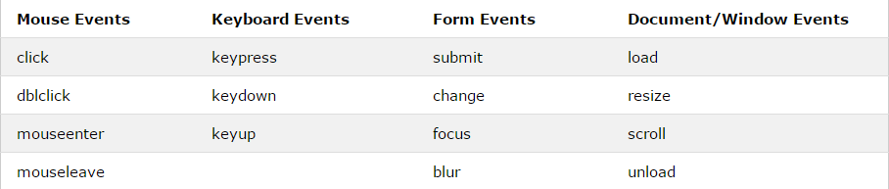
In javascript, we have to separate the function and the attachment. In jQuery, we attach a function to an event handler for the selected elements just in script part.
$("p").click(function(){
alert("The paragraph was clicked.");
});

For instance, in javascript
<script>
document.getElementById("p").onclick=function(){test()};
function test()
{
alert("The paragraph was clicked.");;
}
</script>
while in jQuery:
$("html").mousemove(function(e){
$("#"+puzzle.states[state_number]).css("left",e.pageX+3).css("top",e.pageY+3);
});

This is an example in our project, in this part , we use the event: mousemove to catch the position of users mouse and make the picture do the same movement.
In jQuery library, a lot of common event have be encapsulated in. And they can satisfy most of situation, which are very friendly to the developer.
5. jQuery Effects
The jQuery library provides several techniques for adding animation to a web page. These include simple, standard animations that are frequently used, and the ability to craft sophisticated custom effects.
jQuery Effects provide:
Hide/Show /Fade/Slide/Animate/Stop/Callback/Chaining
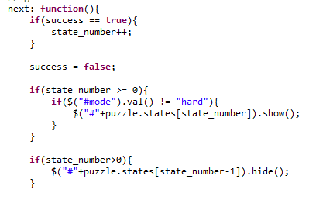
In our application, we use hide and show effect to go to the next state.

And we also use the fade function and animation to make our project more vivid. The callback function helps us to make a more complex animation which is composed with different objects.
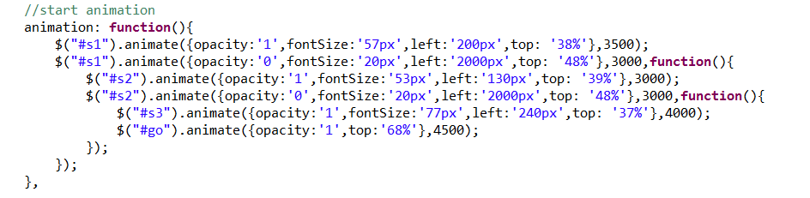

6.jQuery DOM Manipulation
Manipulate the DOM(Document Object Model) is one of the most important part of jQuery.
jQuery comes with a bunch of DOM related methods that make it easy to access and manipulate elements and attributes.
These methods include:
Get/Set-text(),html(), val() and attr();
At the same time, jQuery also provides:
Add/Remove/Manipulating CSS Classes/Manipulating CSS Property

For instance, in our application, we set the value by using attr()

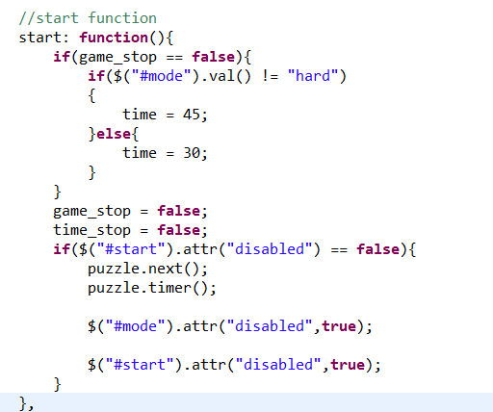

we also use css() to set the style attribute
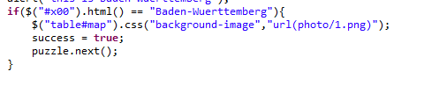

Compared with javascript, the DOM manipulation is much more concise.
To get value from DOM which id is “header” by js:
var element=document.getElementById("header").value;
By jQuery is
var element = $(“#header”).val() ;
7.jQuery Traversing
Rather than seletect html DOM by id or class, jQuery provides the method to find DOM based on their relation.
Ancestors: parent()/parents()/parentsUntil()
Descendants:children()/find()
Siblings:siblings()/next()/nextAll()/nextUntil()/prev()/prevAll()/prevUntil()

In our application, we use next() to traverse sideways in the DOM tree to find siblings of an element
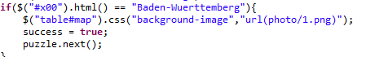

8. jQuery AJAX
Different browsers have different syntax for AJAX(Asynchronous JavaScript and XML) implementation. This means that you will have to write extra code to test for different browsers. However, the jQuery team has taken care of this for us, so that we can write AJAX functionality with only one single line of code. There are mainly three methods in the AJAX.

The load() method can loads data from server instead of reload whole page. Increase the efficiency of web.

In our application, we use the load() method to get start.
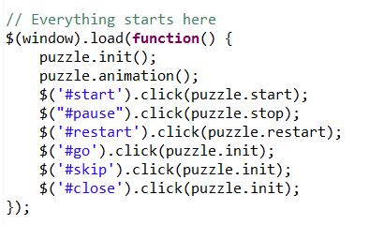
There are two common methods for requesting and responding on the client and server are: GET and POST
GET - Request data from the specified resource
POST - Commits the data to be processed to the specified resource

9. Why jQuery
During the process of completing the project, we have come to realize the characteristics and advantages of using jQuery. These reasons can be concluded as follows:
(1)With jQuery, the manipulation of element is easier
we can set the attributes of many points at the same time which is not possible in javascript.
The specific embodiment in the project is that we set all of the points whose class is Baden-Wuerttemberg with click function with one sentence:
$(".Baden-Wuerttemberg").click(function()

If we use javaScript to complete this task. There will be countless code like onclick = function()to be written.

(2)With jQuery, we create cool effect
In our project, we can change the css attributes so the picture can move with mouse automatically which can not be realized by javascript. We use the event: mousemove to catch the position of users mouse and make the picture do the same movement.
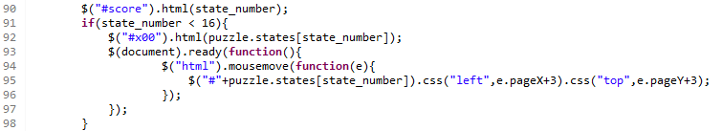

(3)With jQuery, we create cool animation
In our project, we use the “fade in” effect in one line of code to show the win status, which is not possible in javascript. Also, this animation makes our project become more vivid.

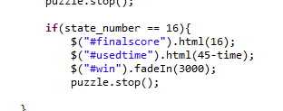
(4)With jQuery, we realize the slogan ”write less, do more”.
Thanks to excellent encapsulation of DOM operations, you do not need to write lengthy code to modify the value of any element of the property or extract from the paragraph or division of the HTML code.

(5)With jQuery, we have great browser compatibility
If there is no jQuery, AJAX programming may have some difficulty. Writing regular AJAX code is not easy, because different browsers do not have the same implementation for AJAX. This means that you must write additional code to test your browser. However, jQuery team solves this problem for us. We only need a simple line of code so that you can achieve AJAX functionality.

